CINERESERVE

Problem-to-Solution Fit Template
IDEATION PHASE • MOVIE TICKET BOOKING PLATFORM

1. Purpose
This template connects moviegoers' problems to a focused, testable CineReserve solution. Statements are hypotheses for validation, not findings from completed user research.

2. Problem-to-solution fit
Template field | CineReserve content
Target user | People who want to discover a movie, compare showtimes, select seats and retrieve a reliable booking confirmation.
Core problem | Movie information, showtimes, seat selection and confirmation can feel fragmented or unclear across a booking journey.
User need | A convenient flow with visible seat status, transparent total price and an easy-to-find ticket.
Current workaround (hypothesis) | Users may switch between movie listings, schedules, seat maps and payment screens.
Proposed value | CineReserve brings discovery, cinema/showtime selection, seat selection, checkout and booking history into one consistent experience.
Expected outcome | Less confusion, fewer avoidable selection errors and easier access to booking details.
Evidence status | Hypothesis. Validate with interviews and prototype usability tests.

3. Problem statement
Problem statement
Moviegoers need a straightforward way to compare movie showtimes and book seats because fragmented information and unclear booking states can make the process confusing. CineReserve will provide a guided journey with clear seat status, pricing and confirmation.

4. User segments and jobs to be done
User segment | Job to be done | Success signal
Casual moviegoer | Find a suitable film and showtime. | Can locate a relevant show without unnecessary navigation.
Group/family planner | Choose seats together and understand total cost. | Seat choices and total price are visible before confirmation.
Returning customer | Find upcoming and previous bookings. | Booking details can be reopened in My Bookings.
Cinema administrator | Maintain movie and showtime information. | Updates are reflected consistently in the booking flow.

5. Pain-point prioritisation
Illustrative workshop estimates only; replace these proportions with findings from real users.
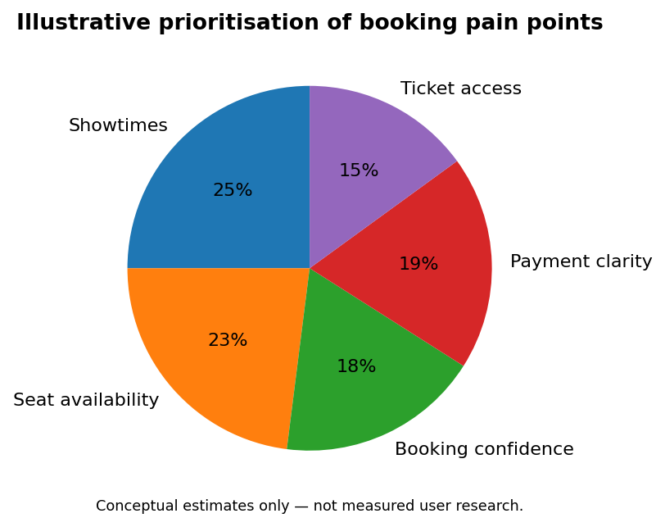

6. Assumptions and validation
Assumption | Validation method | Suggested success criterion
Users value a single booking journey. | 5–8 interviews and prototype testing. | Participants can explain the flow without help.
Seat states must be obvious. | Observe users selecting seats. | Users distinguish available, selected and unavailable seats.
Price transparency builds confidence. | Show itemised total before confirmation. | Users can explain the final price.
Tickets must be easy to retrieve. | Test My Bookings flow. | Participants reopen a booking without assistance.

7. Acceptance checklist
- Problem is written from the user's perspective.
- Target users and tasks are identified.
- Proposed solution addresses the problem directly.
- Assumptions are labelled and have a validation plan.
- Success signals are observable and testable.

8. Scope boundary
Initial scope: movie browsing, city/cinema selection, showtimes, interactive seat selection, booking summary, labelled payment simulation or configured sandbox, digital ticket and booking history. Do not claim real payment processing until a provider is configured and tested.

